**GIT – HOL 5**

The following steps were followed to complete this exercise:

Again, working on the same Branching_Merging repo created in 3rd hands-on.

1. 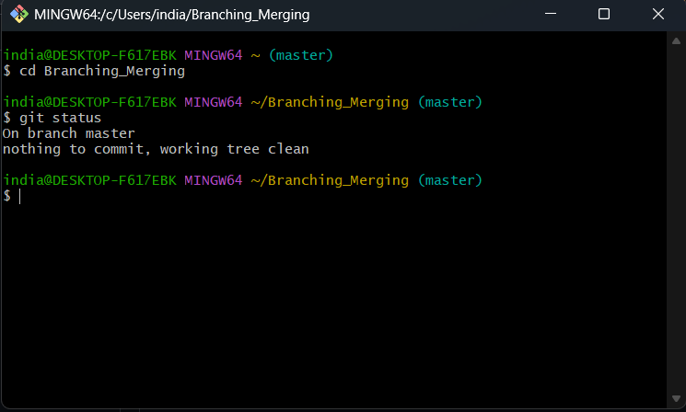Verifying if master is in clean state

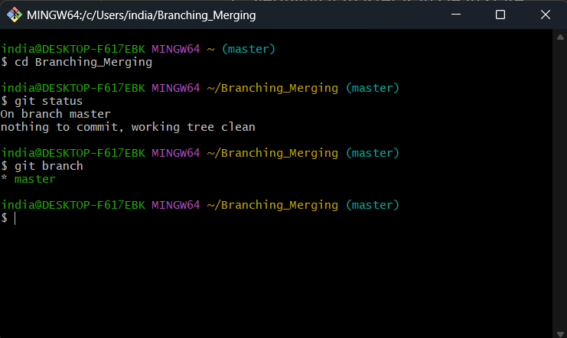2.Listing out all the available branches

3. Pulling the remote git repository to the master

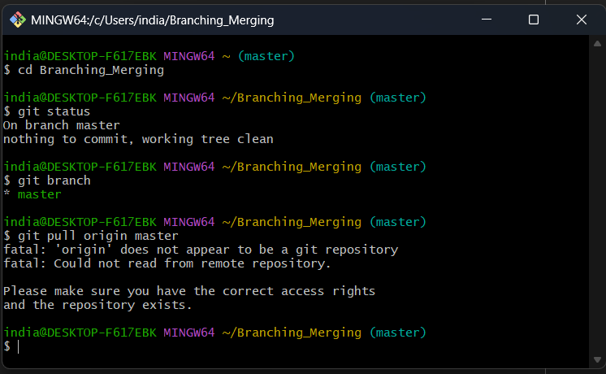Since currently no working directory is linked therefore, we are getting this message

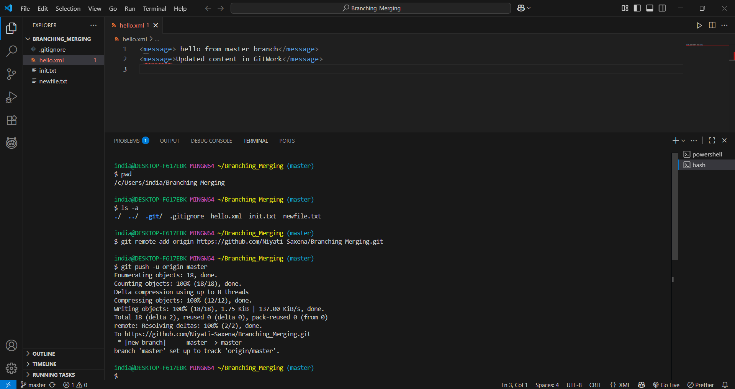4. Linking local repo to Git repo and then pushing the changes to remote repo.

5. As we can see the logs of all the commits we made locally are now being reflected on the remote repository.

